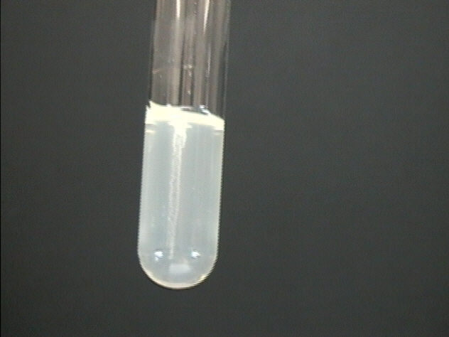

You have received a bacterial stab. A stab is made by dipping a sterile loop into bacteria and then literally stabbing it into a semi-solid agar media. This creates a semi-sealed culture along the line of the stab. In your stab you should see a similar whiteish line in the middle of the tube that contains bacterial growth. If you are having a hard time seeing the stab hold it up to the light. If you still see nothing let the tube sit out at room temperature overnight for the bacteria to grow.

In order to access the bacteria, use an inoculation loop and try and stick it along the same line as the stab. Then take the loop and gently streak it along a plate or use it to make a liquid culture for future use like DNA purification.